Necessary Packages:
Library(dplyr)
Library(ggplot2)
Library(fpc)
Library(caret)
Library(gmmnet)
Library(ranger)
Library(e1071)
Library(clValid)
DataSet Description:
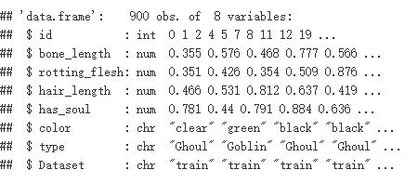
Use Summary(full)
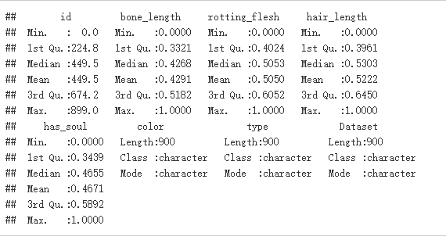

Distribution of Continuous Variables by Creature Type
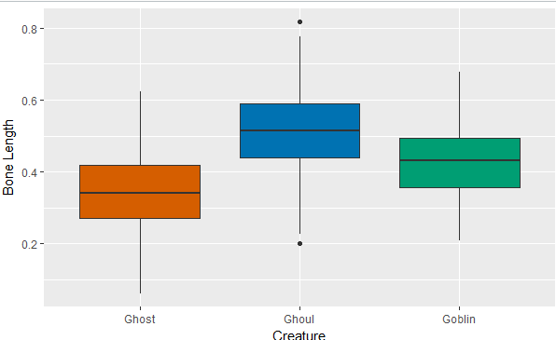
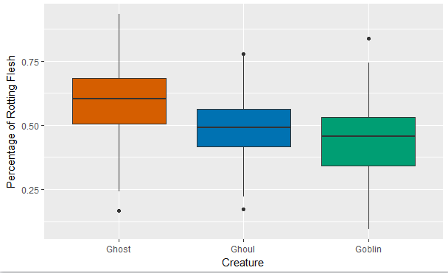
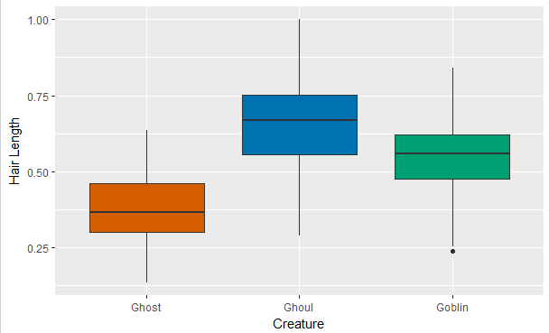
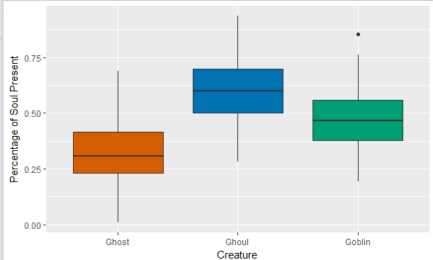

Distribution of Color by Creature Type

Ghost:

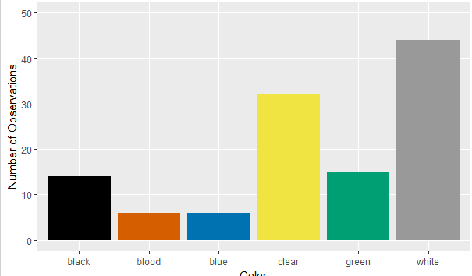
Ghoul:
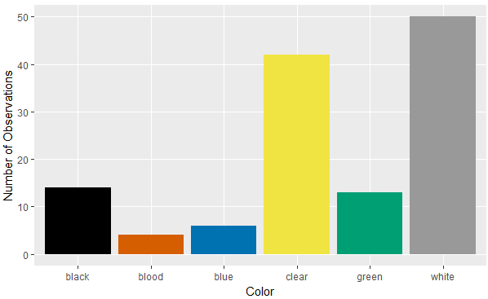
Goblin:

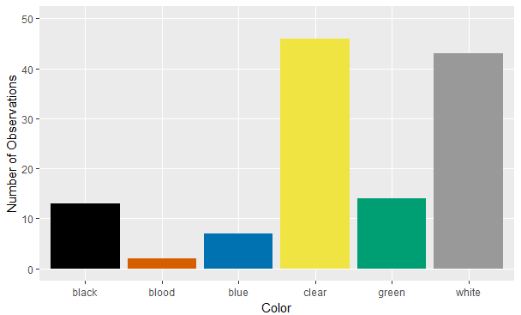

Feature: Using base graphics, function “pairs”, to visualize pairwise comparisons
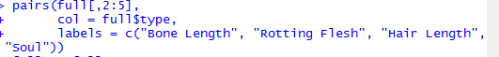
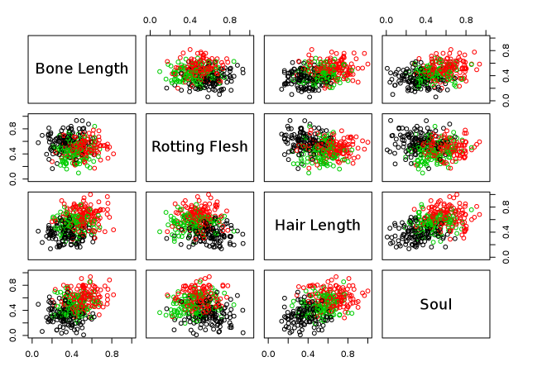

Other features, combination of characteristics into one may show better separation among creatures
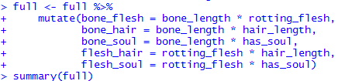
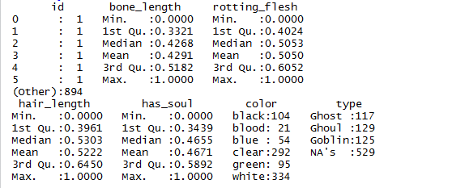
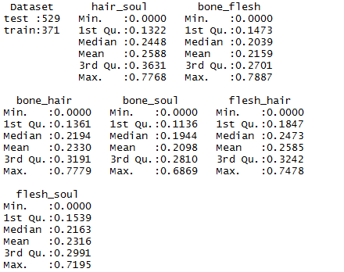
Methods

First, creating the train Controler, use caret library, create system will perform 20 repeats of a 10-fold cross validation for the data. Second , apply the Random Forest Model: use ranger and caret packages, include all of the original variables, including interactions, set the tuneLength to 3, use the “ranger” method, , set the train control and importance parameter, later we will tune the parameter to find the best accuracy. And then we try to use the ggplot to see the importance of factors. We found that color is not so important. Then we try ignor color factor to make a result to compare, we may get another better result to compare.
According the same controller and tune lamda parameter, we get glmnet model , we get the result compare with random forest. Glmnet modle is better.
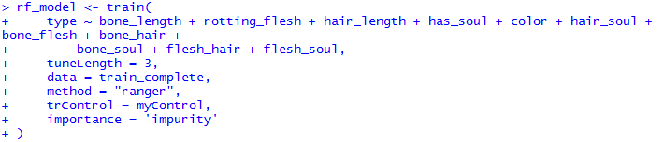
Importance of fators:
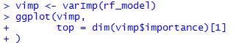
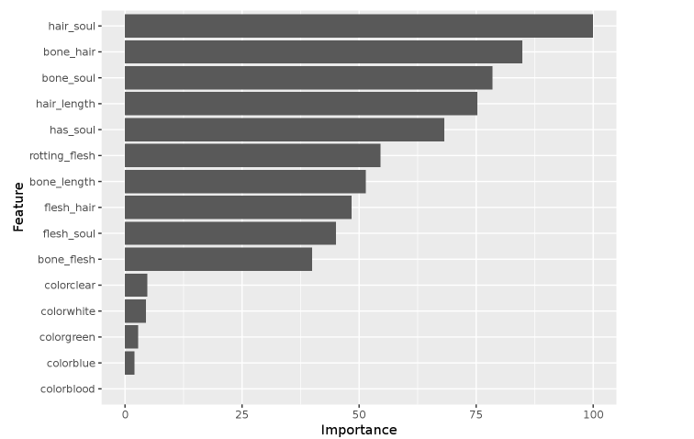
“hair_soul” variable is the most important in this model and other interactions rank pretty highly. We can keep them. Color, is not so important we think , so we can remove them and try another random forest in the second random forest model.

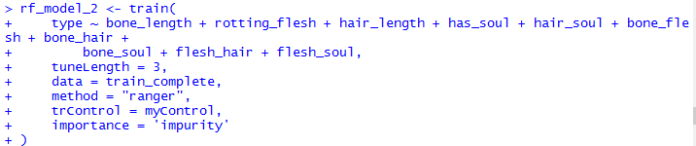

With the same feature , use glmnet model:
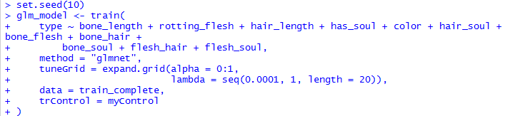
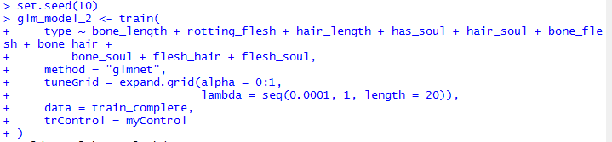
Comparing model fit:
Random forest:
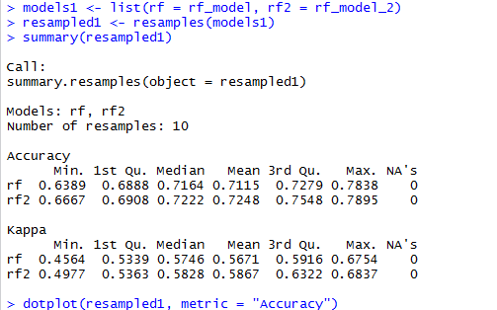
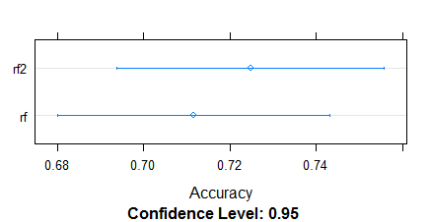
Glmnet model:
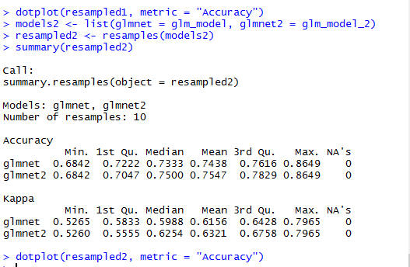
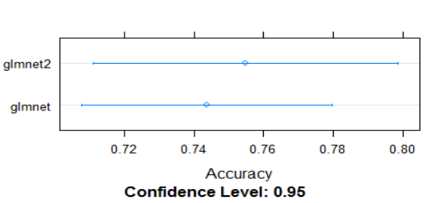

Experimental results and analysis
 | classsifier | folder | repeat | tuneLength | alpha | seq | length | accuracy
1 | randomforest | 10 | 20 | 3 |  |  |  | 78.95
2 | randomforest | 10 | 10 | 3 |  |  |  | 78.49
3 | randomforest | 10 | 200 | 5 |  |  |  | 78.38
4 | randomforest | 10 | 500 | 5 |  |  |  | 78.95
5 | randomforest | 10 | 20 | 10 |  |  |  | 78.9
6 | glmnet | 10 | 20 |  | 0:1 | 0.0001 | 20 | 86.49
7 | glmnet | 10 | 20 |  | 0:1 | 0.0001 | 50 | 86.21
8 | glmnet | 10 | 20 |  | 0:1 | 0.0001 | 200 | 86.49
9 | glmnet | 10 | 200 |  | 0:1 | 0.0001 | 50 | 86.49
10 | glmnet | 10 | 200 |  | 0:1 | 0.001 | 20 | 86.2

ghosts have shorter hair and fewer pieces of soul than ghouls and goblins, but others are close. Ghouls and goblins are going to be tricky to distinguish. Color doesn’t appear to help to distinguish the creatures. hair_soul” is most important to this model , and color feature is not so important as we think , so we can take the color factor aside to pay attention to other important factor to create the model. In randomforest , It has a mean accuracy of 72.5% ,after tuning the parameter, and it has 78.49% accuracy . but glmnet model has a more higher accuracy ,it has 78.29 for mean accuracy, after changes some parameter, it has 86% accuracy. And if we take out the color factor, we have a higher accuracy than the previous all factors exist.

